**Highlight of Contributions**

**First Author, Second Author, Third Author**

* contribution 1
* contribution 2
* contribution 3

This is the Title Format for Innovative Informatics and Artificial Intelligence Research (IIAIR)

**First aut[](https://orcid.org/0000-XXXX-0689-XXXX)hor 1, Second author**[](https://orcid.org/0000-XXXX-0689-XXXX) **1, and Third author2**

1Department, University, City, Country

2Department, University, City

*Corresponding author: First Author (*[*author1@itk.ac.id*](mailto:author1@itk.ac.id)*)*

**To cite this article:** A. First, A. Second, A. Third, “Title of the manuscript: IIAIR,” *Innovative Informatics and Artificial Intelligence Research*, vol. 1, no 1, 2024. [Online]. Available: <https://journal.itk.ac.id/index.php/IIAIR>

**Abstract**

These are guidelines for preparing papers for the *Innovative Informatics and Artificial Intelligence Research (IIAIR)*. The journal accepts original research papers, surveys, and tutorial articles within the broad field of informatics and/or artificial intelligence. Use this document as a template if you are using Microsoft Word or LibreOffice Writer. Otherwise, we have an option to use the LaTeX template that is available on <https://journal.itk.ac.id/index.php/IIAIR>

**Keywords:** artificial intelligence; machine learning; deep learning; informatics

# Introduction

This document is a template for Microsoft word or Libre office. Please use the electronic version of this document as a template when you produce your manuscript for submission to the *Innovative Informatics and Artificial Intelligence Research (IIAIR)*. The paper size is A4 (21 × 29.7 cm).

These are the examples of subsection

## 1.1 Sub section 1

This is a subsection of the introduction. The detailed information on the methods is described in Section 3. Another important piece of information is discussed in Section 1.1.1.

### 1.1.1 Sub-sub section 1

This is a subsection of sub-section 1

# 2. Related Works

This section is intended for your literature review and recent discussion. Example of multiple citations [1, 2, 3]**.** Single citation [4]. Please use IEEE format for citation style and please utilize the references manager like Zotero or Mandeley to cite an article.

# 3. Methods

In the methods section, please describe all necessary information about your methods.

This is an example of a figure template in IIAIR LaTeX format. Please use bold style text in a caption as shown in Figure 1**.**

Figures may be in color or black and white and must be of such quality that they produce clear and sharp printouts on an ordinary (color) laser printer.

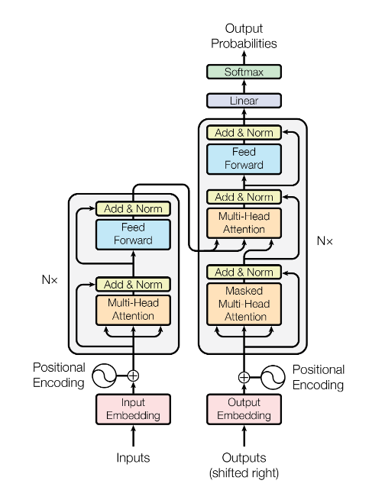Figure : The transformer network model [5]

The example equation is referenced as Equation 1.

(1)

# 4. Results and Discussions

This section is intended for the results and your discussion.

The table format can be seen in Table 1. The table’s style is by adding a top and bottom line in the title for each column and a bottom line at the end of the content in the table.

Table : Example of table format

|  |  |  |
| --- | --- | --- |
| head1 | head2 | head3 |
| content1 | content2 | content3 |
| content1 | content2 | content3 |

# 5. Conclusions

Conclusion section

# Acknowledgments

Acknowledgments section if necessary

# References

1. Samples of formatted references for authors of journal articles. National Library of Medicine. [Online]. Available: <http://www.nlm.nih.gov/bsd/uniform_requirements.html>
2. S. D. Halpern, P. A. Ubel, and A. L. Caplan, “Solid-organ transplantation in HIV-infected patients,” *New England Journal of Medicine*, vol. 347, pp. 284–7, 2002.
3. M. E. Rose, M. B. Huerbin, J. Melick, D. W. Marion, A. M. Palmer, J. K. Schiding et al., “Regulation of interstitial excitatory amino acid concentrations after cortical contusion injury,” *Brain Research*, vol. 935(1-2), pp. 40–6, 2002.
4. P. R. Murray, K. S. Rosenthal, G. S. Kobayashi, and M. A. Pfaller, *Medical microbiology*, 4th ed. St. Louis: Mosby, 2002.
5. A. Vaswani, N. Shazeer, N. Parmar, J. Uszkoreit, L. Jones, A. N. Gomez, L. u. Kaiser, and I. Polosukhin, “Attention is all you need,” in Advances in Neural Information Processing Systems, I. Guyon, U. V. Luxburg, S. Bengio, H. Wallach, R. Fergus, S. Vishwanathan, and R. Garnett, Eds., vol. 30. Curran Associates, Inc., 2017. [Online]. Available: https://proceedings.neurips.cc/paper_files/paper/2017/file/3f5ee243547dee91fbd053c1c4a845aa-Paper.pdf